Installing Progress 10.2B – Windows

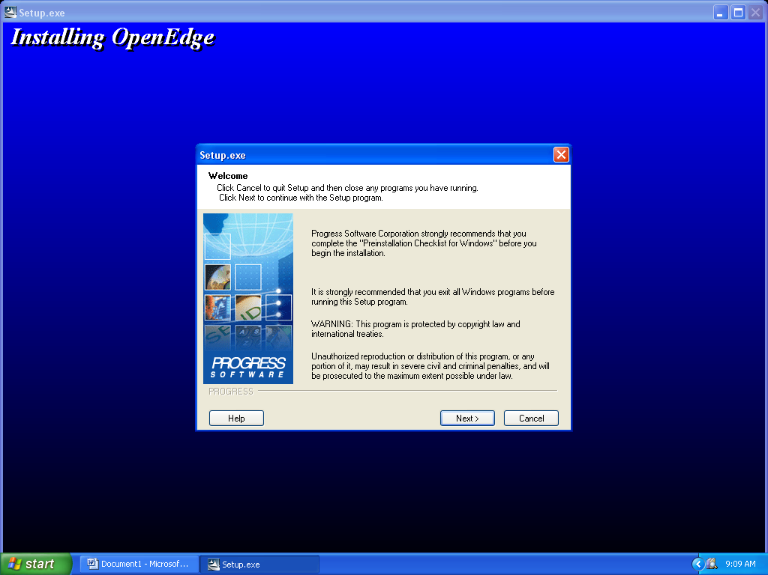
Welcome Screen

- Place Progress CD in Drive – The CD will auto load to the first screen
- Click [NEXT]

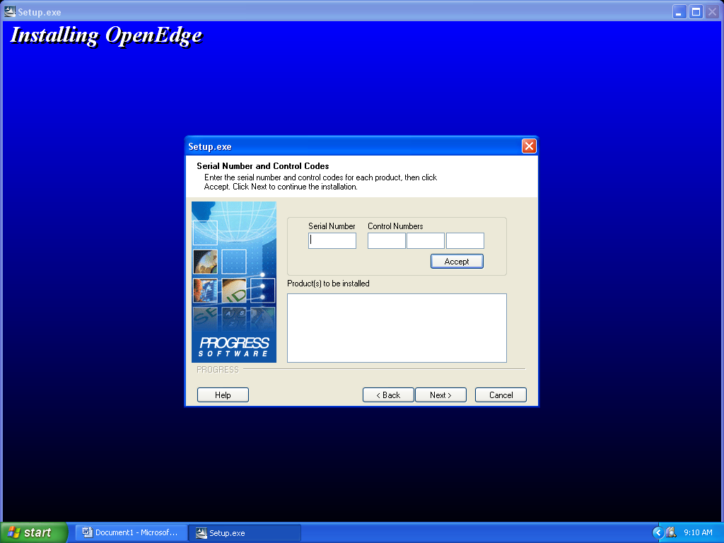
Serial Number and Control Codes

- Enter your serial and control numbers for each product that you are installing.

- Install two products for the server - (OE Workgroup RDBMS) – (Client Networking)

- Install one product for the client – (Client Networking)

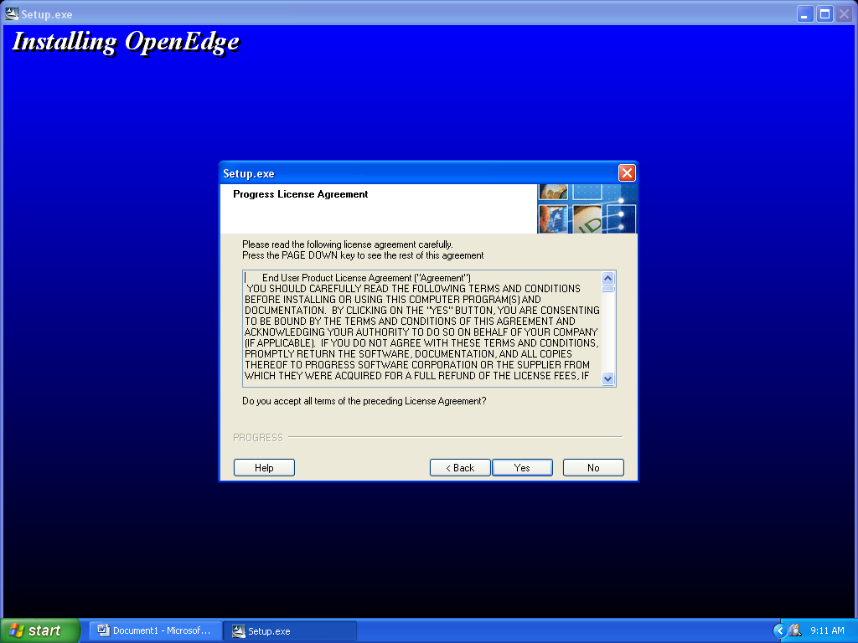
Progress License Agreement

- Accept the terms and conditions and then click [YES] to continue.

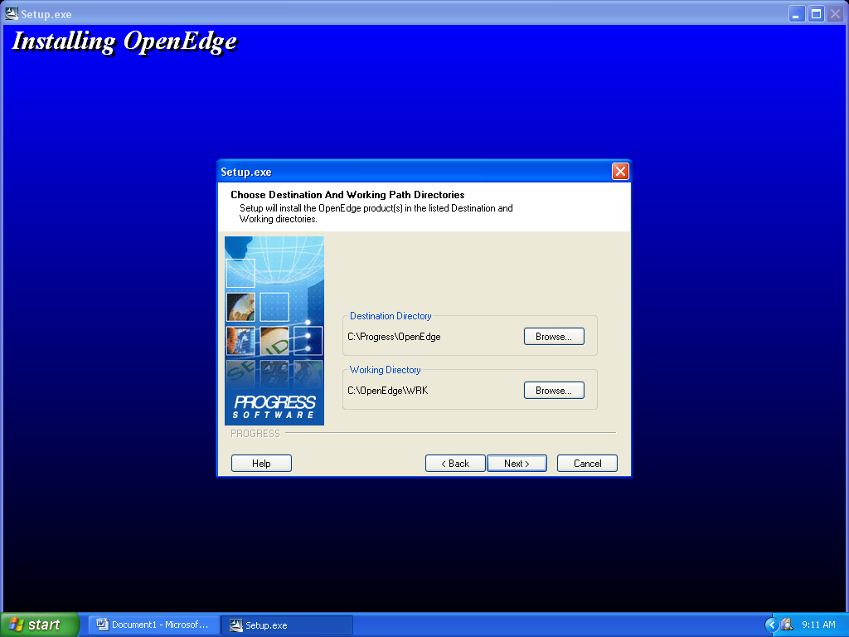
Chose Destination and Working Path Directories

- Accept default settings and then click [NEXT] to continue to the next screen

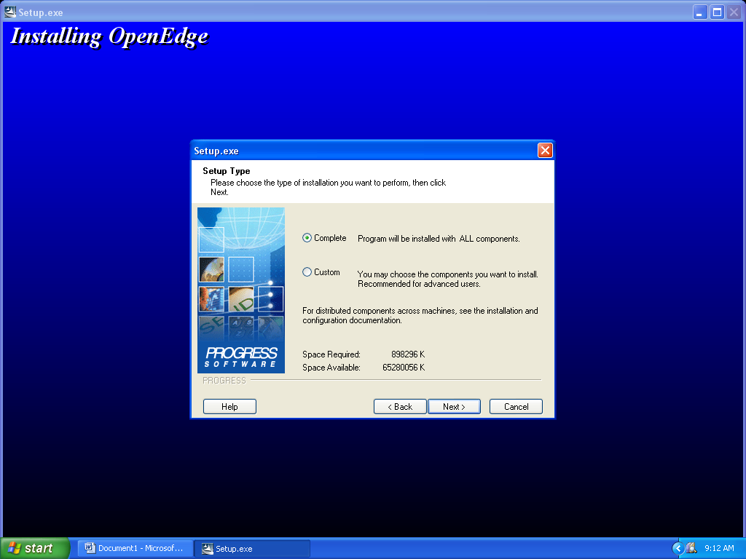
Setup Type

- Take default settings, make sure that the [Complete Installation] is checked and then click [NEXT]

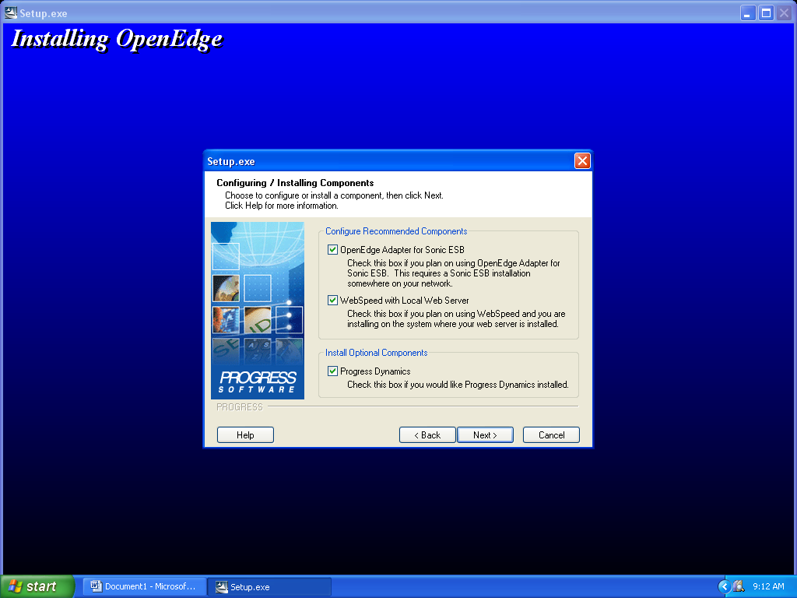
Configuring / Installing Components

- Keep the default settings and click [NEXT]

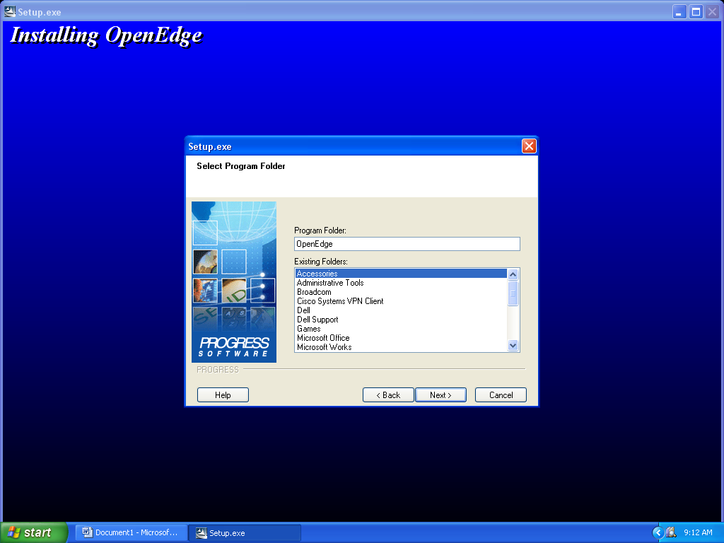
Select Program Folder

- Keep the program folder name the same as the default settings and click [NEXT]

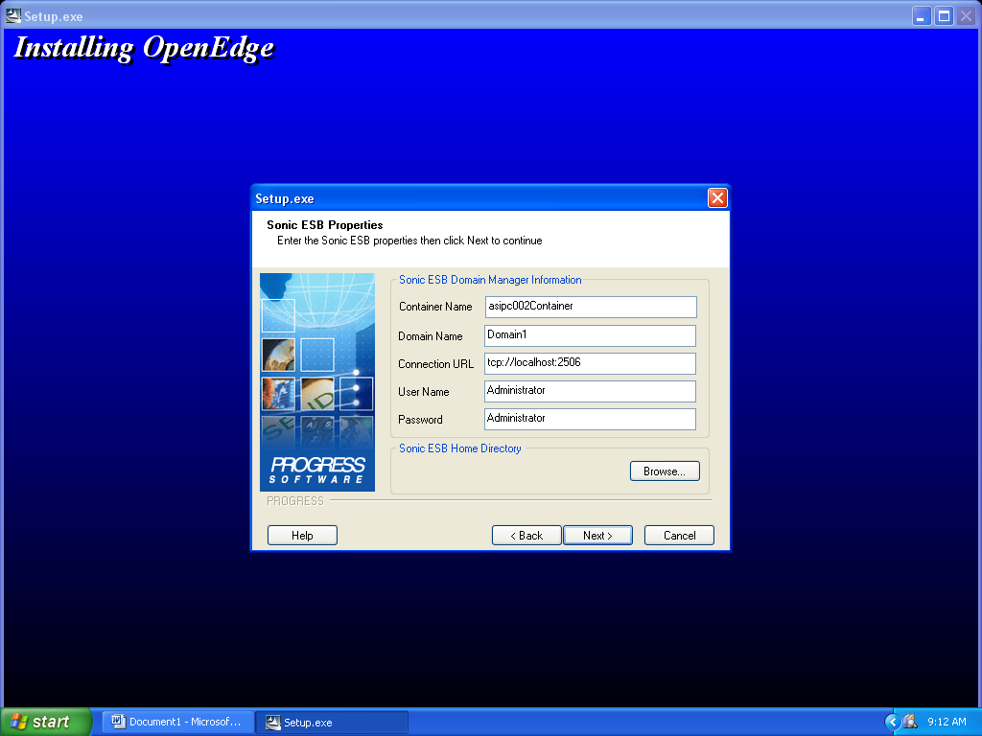
Sonic ESB properties

- Keep the settings that are on the screen and click [NEXT]

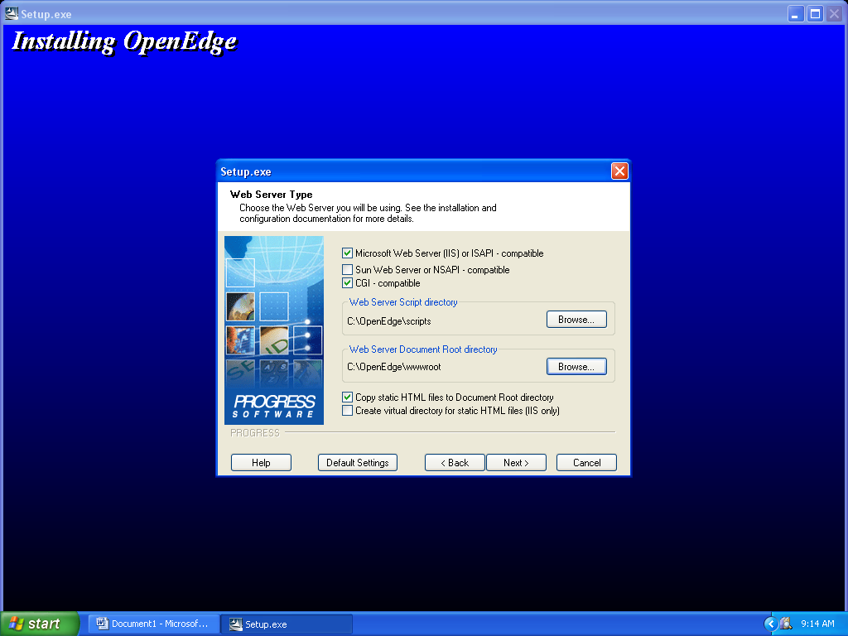
Web Server Type

- Make sure that the settings are the same as on this screen image and click [NEXT]

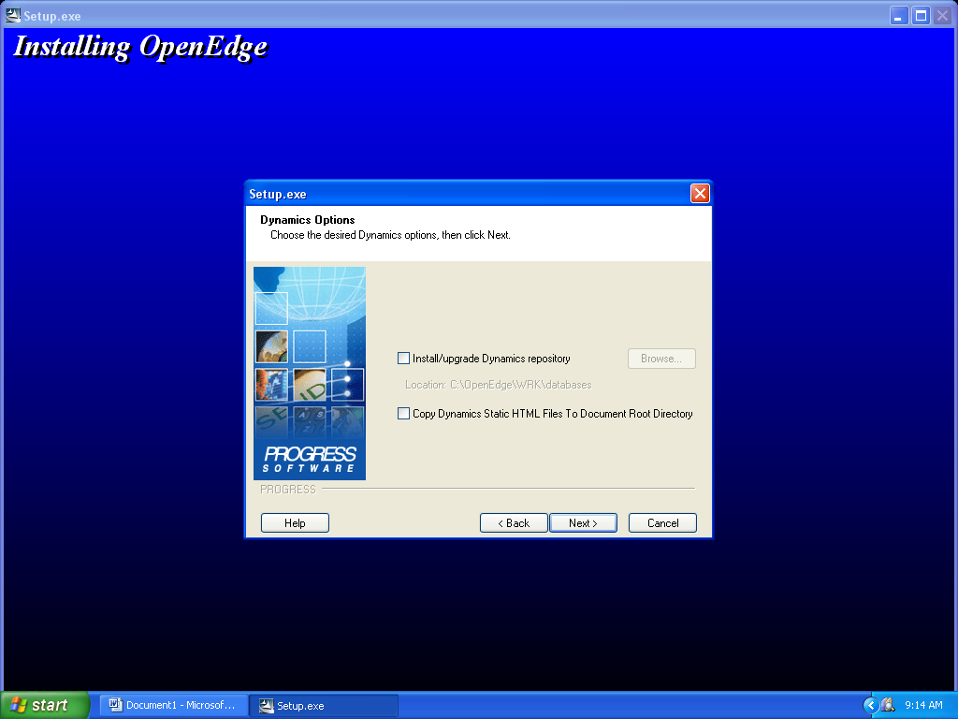
Dynamics Options

- Accept default and click [NEXT] (You should have no checks for the selections)

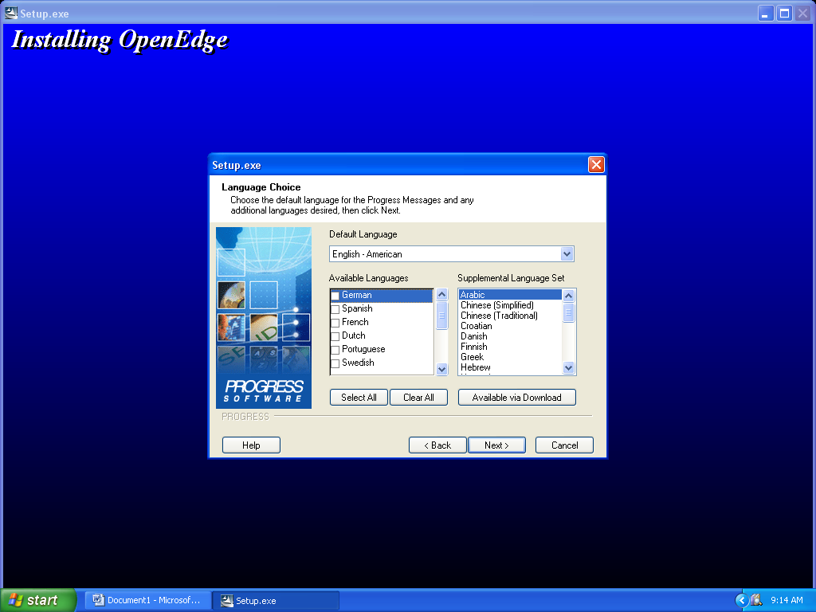
Language Choice

- Make sure that English – American is selected on the screen
- Click [NEXT] to continue

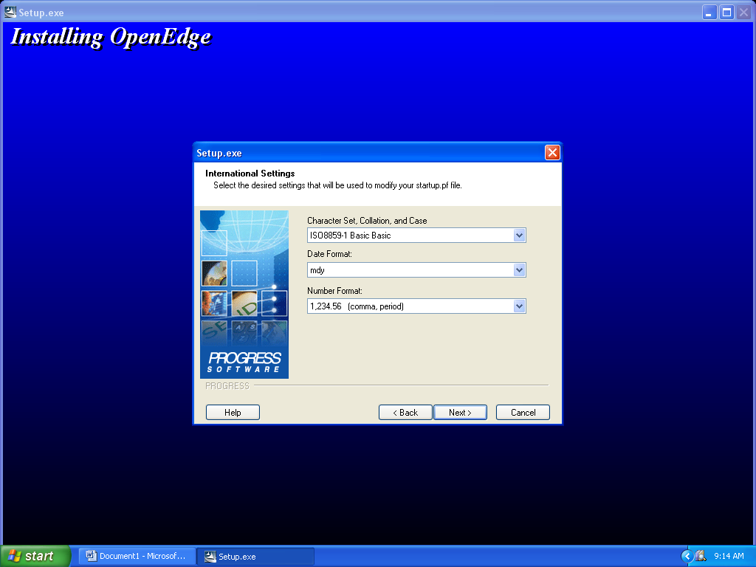
International Settings

- Keep all default settings on the screen and click [NEXT]

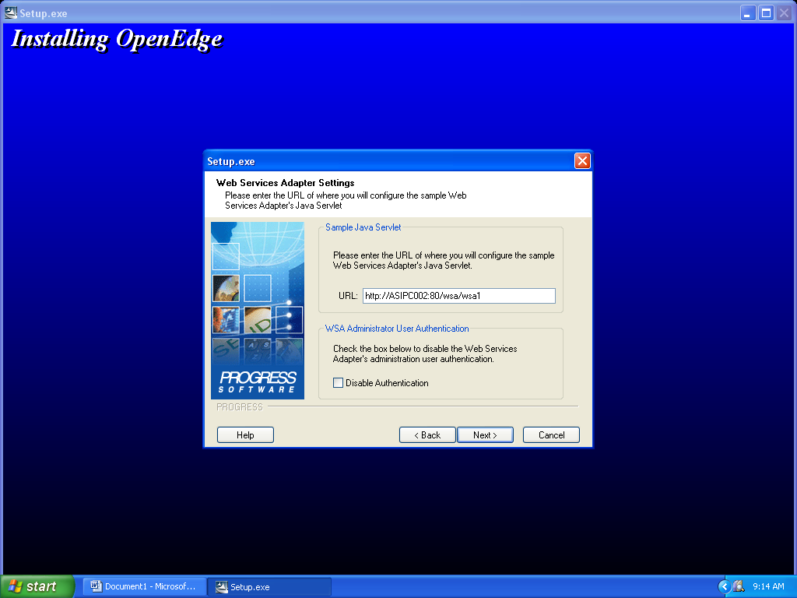
Web Services Adapter Settings

- Keep the default settings and click [NEXT]

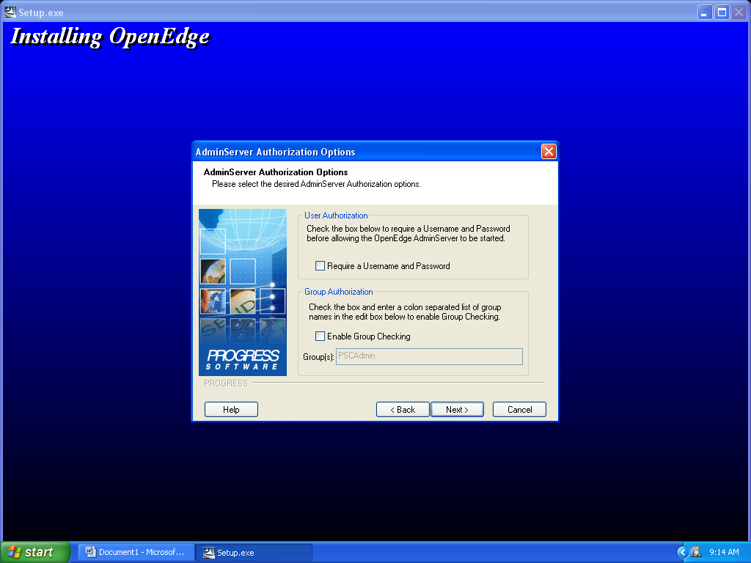
AdminServer Authorization Options

- Do not check any boxes and take the default settings and click [NEXT]

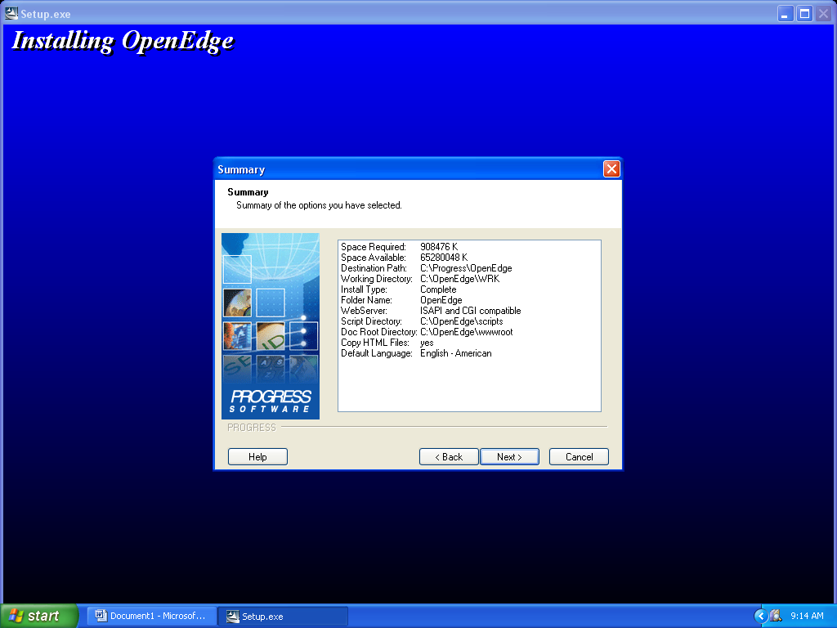
Summary

- View your summary selection and then click [NEXT]

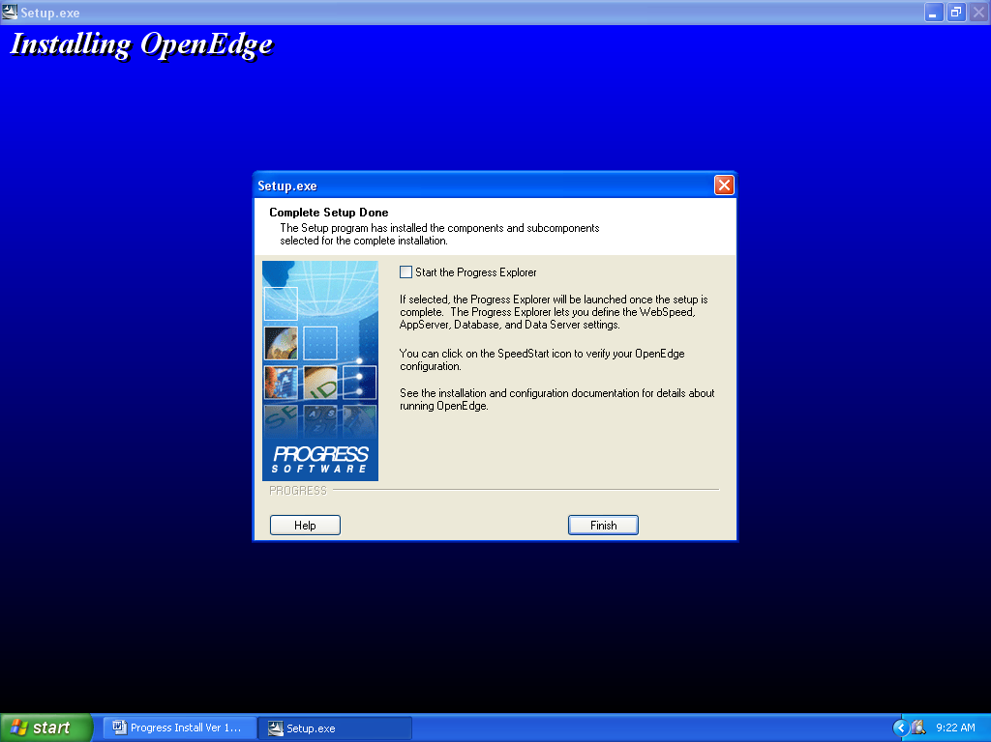
Complete Setup Done

- When setup is done you will click [Finish]
- The Progress application is know installed on your system

- Complete Installation

- Install Progress 10.2B 07
Patch Disk

